Nama : Kianne Rista Tanayu

NIM : 12030123140214

Mata Kuliah : Pengkodean & Pemrograman

Kelas : D

**TUGAS 3**

**Aplikasi Persediaan & Penjualan**

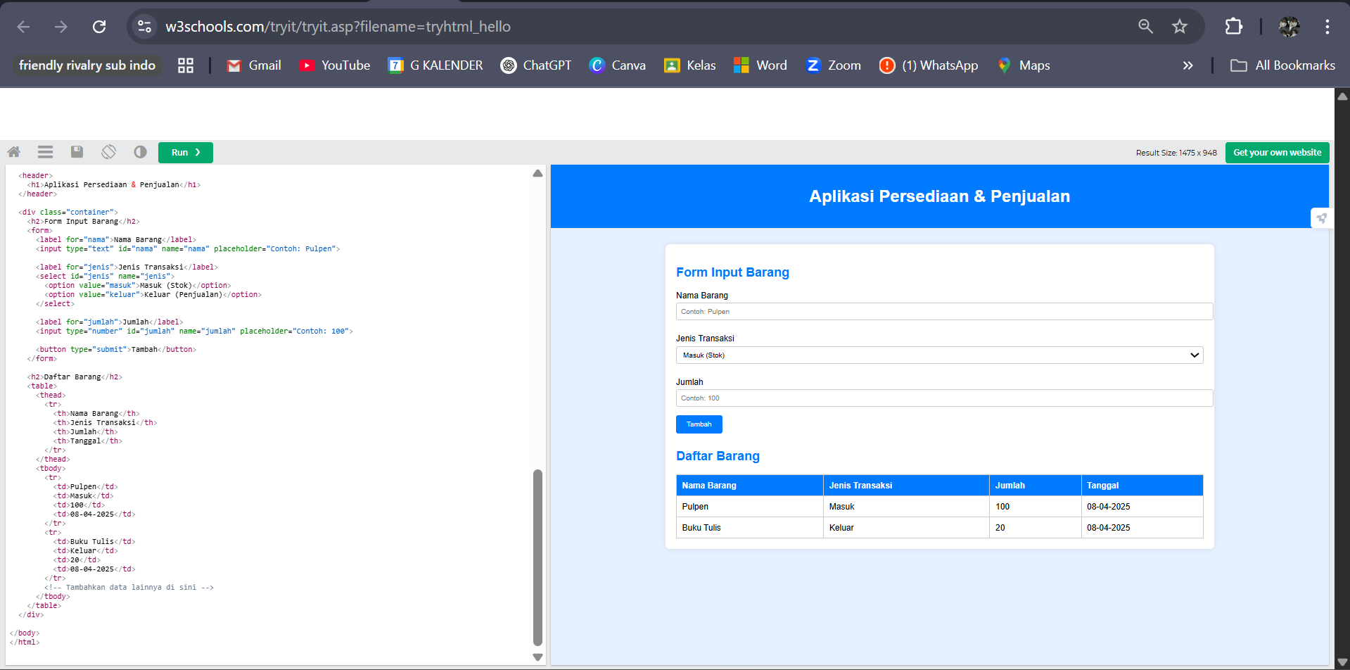

Codingannya:

<!DOCTYPE html>

<html lang="id">

<head>

<meta charset="UTF-8">

<title>Aplikasi Persediaan & Penjualan</title>

<style>

body {

font-family: Arial, sans-serif;

background-color: #e6f0ff;

margin: 0;

padding: 0;

}

header {

background-color: #007BFF;

color: white;

padding: 20px;

text-align: center;

}

.container {

max-width: 1000px;

margin: 30px auto;

padding: 20px;

background-color: #ffffff;

border-radius: 8px;

box-shadow: 0 0 10px rgba(0,0,0,0.1);

}

h2 {

color: #007BFF;

}

form {

margin-bottom: 30px;

}

label {

display: block;

margin: 10px 0 5px;

}

input, select {

width: 100%;

padding: 8px;

margin-bottom: 15px;

border: 1px solid #ccc;

border-radius: 4px;

}

button {

background-color: #007BFF;

color: white;

padding: 10px 20px;

border: none;

border-radius: 4px;

cursor: pointer;

}

button:hover {

background-color: #0056b3;

}

table {

width: 100%;

border-collapse: collapse;

margin-top: 20px;

}

table, th, td {

border: 1px solid #ccc;

}

th, td {

text-align: left;

padding: 10px;

}

th {

background-color: #007BFF;

color: white;

}

</style>

</head>

<body>

<header>

<h1>Aplikasi Persediaan & Penjualan</h1>

</header>

<div class="container">

<h2>Form Input Barang</h2>

<form>

<label for="nama">Nama Barang</label>

<input type="text" id="nama" name="nama" placeholder="Contoh: Pulpen">

<label for="jenis">Jenis Transaksi</label>

<select id="jenis" name="jenis">

<option value="masuk">Masuk (Stok)</option>

<option value="keluar">Keluar (Penjualan)</option>

</select>

<label for="jumlah">Jumlah</label>

<input type="number" id="jumlah" name="jumlah" placeholder="Contoh: 100">

<button type="submit">Tambah</button>

</form>

<h2>Daftar Barang</h2>

<table>

<thead>

<tr>

<th>Nama Barang</th>

<th>Jenis Transaksi</th>

<th>Jumlah</th>

<th>Tanggal</th>

</tr>

</thead>

<tbody>

<tr>

<td>Pulpen</td>

<td>Masuk</td>

<td>100</td>

<td>08-04-2025</td>

</tr>

<tr>

<td>Buku Tulis</td>

<td>Keluar</td>

<td>20</td>

<td>08-04-2025</td>

</tr>

<!-- Tambahkan data lainnya di sini -->

</tbody>

</table>

</div>

</body>

</html>